How to improve Amazon CDQ score.

亚马逊CDQ 6个核心指标 权重
How to improve Amazon CDQ score.

本文主要讲解亚马逊CDQ核心指标，以及Sub Category Score
CDQ主要是指亚马逊综合数据质量 Amazon Composite Data Quality，重点6个指标

CDQ
Completing Required Product Attributes
Understand how Amazon's Composite Data Quality (CDQ) score measures your listing quality and directly impacts search visibilityand sales. Learn the six core components that determine whether your products rank as A-grade or face suppression.
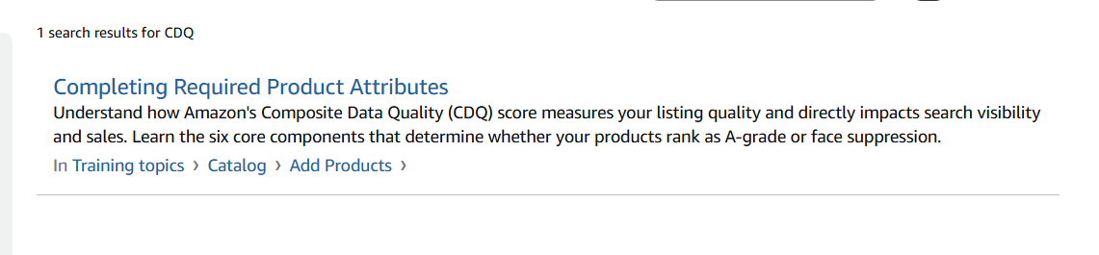
CDQ composite data quality score
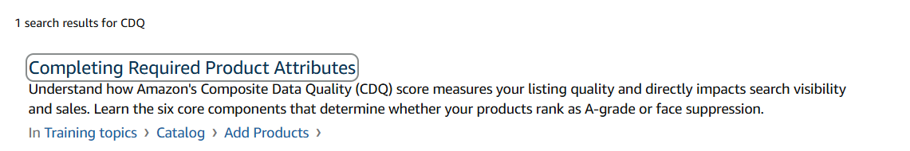
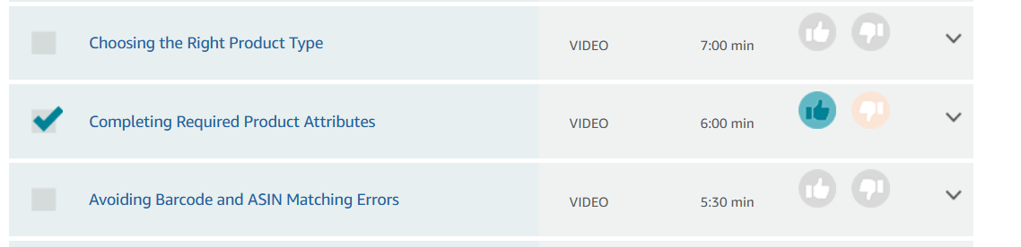
How do I improve my CDQ score?

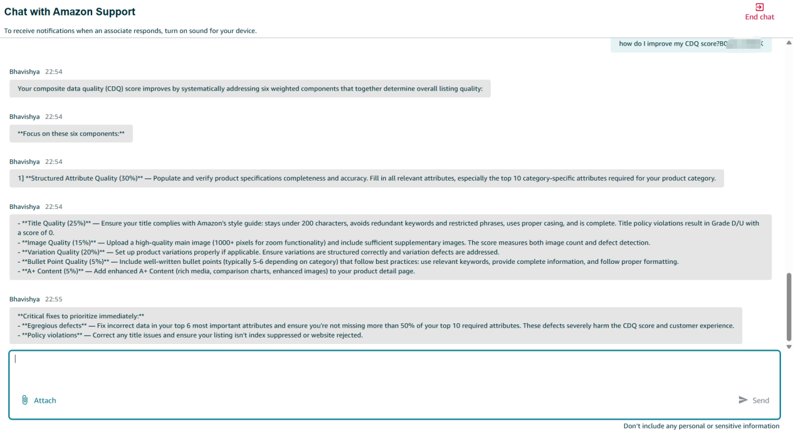
Your composite data quality (CDQ) score improves by systematically addressing six weighted components that together determine overall listing quality:

Focus on these six components:

1] Structured Attribute Quality (30%) — Populate and verify product specifications completeness and accuracy. Fill in all relevant attributes, especially the top 10 category-specific attributes required for your product category.

- Title Quality (25%) — Ensure your title complies with Amazon's style guide: stays under 200 characters, avoids redundant keywords and restricted phrases, uses proper casing, and is complete. Title policy violations result in Grade D/U with a score of 0.
- Image Quality (15%) — Upload a high-quality main image (1000+ pixels for zoom functionality) and include sufficient supplementary images. The score measures both image count and defect detection.
- Variation Quality (20%) — Set up product variations properly if applicable. Ensure variations are structured correctly and variation defects are addressed.
- Bullet Point Quality (5%) — Include well-written bullet points (typically 5-6 depending on category) that follow best practices: use relevant keywords, provide complete information, and follow proper formatting.
- A+ Content (5%) — Add enhanced A+ Content (rich media, comparison charts, enhanced images) to your product detail page.
Critical fixes to prioritize immediately:
- Egregious defects — Fix incorrect data in your top 6 most important attributes and ensure you're not missing more than 50% of your top 10 required attributes. These defects severely harm the CDQ score and customer experience.
- Policy violations — Correct any title issues and ensure your listing isn't index suppressed or website rejected.
亚马逊官方解答：
The first 6 RAI attributes are the top 6 most important product attributes for your specific product type, identified by a Natural Language Processing (NLP) model called Relevance Attribute Index (RAI).

Band A attributes :
- Help identify and describe the essential nature of the product
- Describe fundamental characteristics that identify the product's core attributes
- Differentiate the product from other similar items
- Examples: For a laptop, this might include processor type, RAM, operating system, or display size

Band B attributes :
- Key product characteristics that differentiate between variants and versions of the same product type
- Allow customers to select their preferred option
- Attributes that differentiate between similar products
- Examples: For a laptop, this might include color, connectivity options, or specific port types
Together, Band A and B attributes form the "Depth Widget" — the detailed information visible on the product detail page that helps customers make informed purchasing decisions.

The first 6 RAI attributes are NOT fixed — they vary by product type. They are determined by the Relevance Attribute Index (RAI), an NLP model that ranks attributes differently for each category based on customer behavior.

What makes them "first":
The RAI model ranks all attributes for your product type (1st, 2nd, 3rd, etc.) based on which attributes customers care about most. This is determined by analyzing:
- Customer reviews
- Customer Q&A conversations
- Search queries
- Product titles and descriptions
- Manufacturer and competitor websites
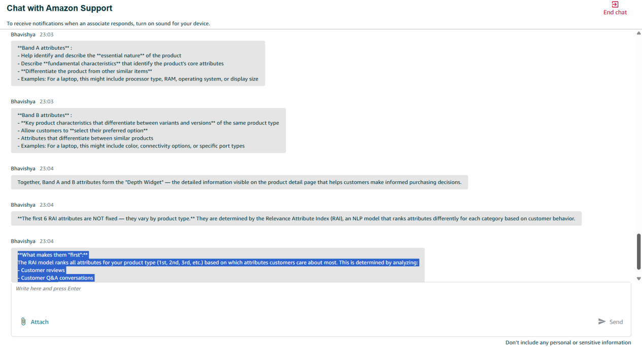
Bhavishya
23:10
Discoverability refers to initiatives focused on helping customers find products through search and browse experiences. It involves:
- New Product Launch (NPL) Discoverability — A structured process to ensure new products are discoverable and visible to customers during launch
- Tracking key metrics across the customer funnel: Traffic (Glance Views per 100k customers)
Consideration (Add-to-Cart/Glance Views)
Conversion (Units/Glance Views)
- Tools like DART (Discoverability Analytics & Research Tool) — Provides insights into what customers are looking for from a search perspective and identifies attributes that require enrichment

For New Product Launches, the process includes:
- 6-12 months pre-launch: Submit NPL details and develop launch strategy
- Attend SAS Discoverability Office Hours (if Priority 1 or 2)
- 4-6 weeks prior: Submit A+ Content, enroll in Vine
- Launch day activities: Walk the store, ensure search/display campaigns are running
Product Type Classification is the system that determines the category/product type for an ASIN. Key points:
- Not yet launched in all marketplaces — For example, PT Classification is not yet launched in IE (Ireland) marketplace
- The classification affects how products are organized, searched, and filtered on Amazon
ETATBD stands for "Estimated Time to Availability"
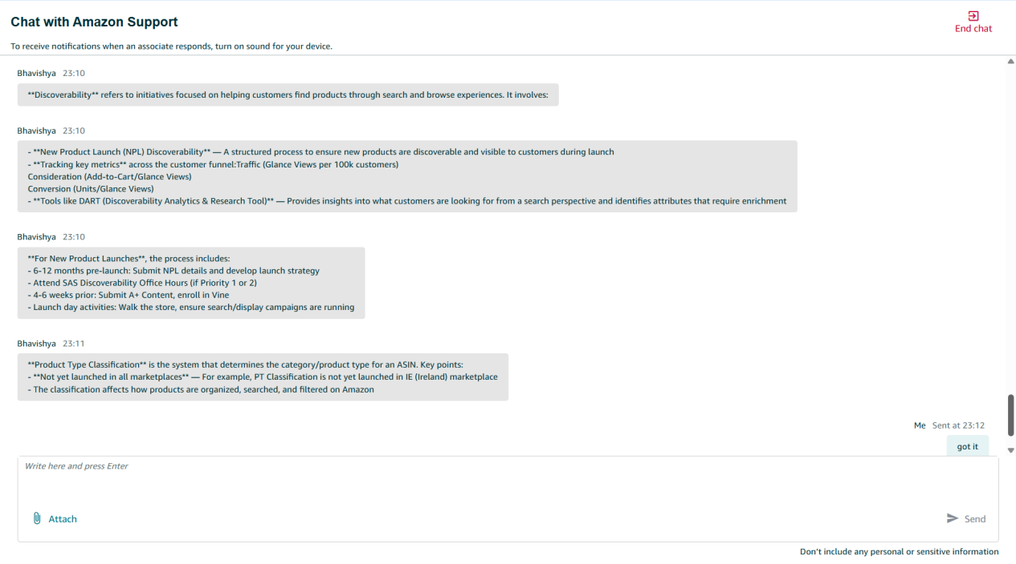
"N/A weight" in the context of CDQ refers to components that are not applicable to certain ASIN types. Here's the breakdown:

Variation Quality — 20% Weight (or N/A for Orphan ASINs)
Component Variation ASIN Weight Orphan ASIN WeightVariation Quality20%N/A (redistributed)
What this means:
- Variation ASINs (products that come in different options/sizes/colors) — Variation Quality is evaluated at 20% weight
- Orphan ASINs (standalone products NOT in a variation family) — Variation Quality is N/A because it's not applicable
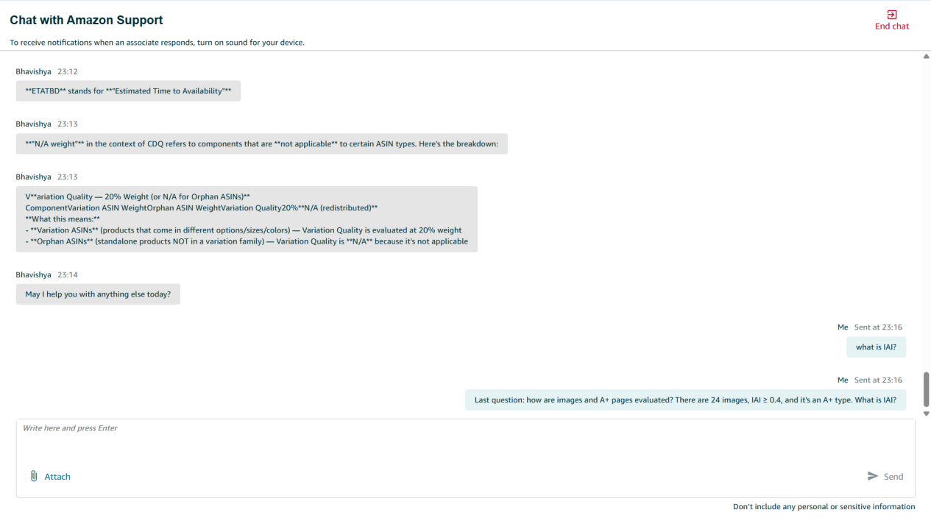

here's how images and A+ pages are evaluated in CDQ:Image Quality Evaluation (15% weight / 18.75% for orphans)
How your 24 images score:
Your ASIN has 24 website-active images, which exceeds the 4-image minimum. The Image Quality score depends on whether there are any image defects:
Condition Score Image count ≥ 4 AND **no image defects1.0 (100%)**Image count ≥ 4 AND **has image defects0.4 (40%)**Image count < 4 AND no defects0.6 (60%)Image count < 4 AND has defects0.0 (0%)
Since you have 24 images (far exceeding 4), your score is either:
- 1.0 — if no image defects are detected
- 0.4 — if any image defects exist
IAI stands for Imaging Attribute Index — a metric that measures the quality and completeness of product images on your catalog.
IAI stands for Imaging Attribute Index — a metric that measures the quality and completeness of product images on your catalog.

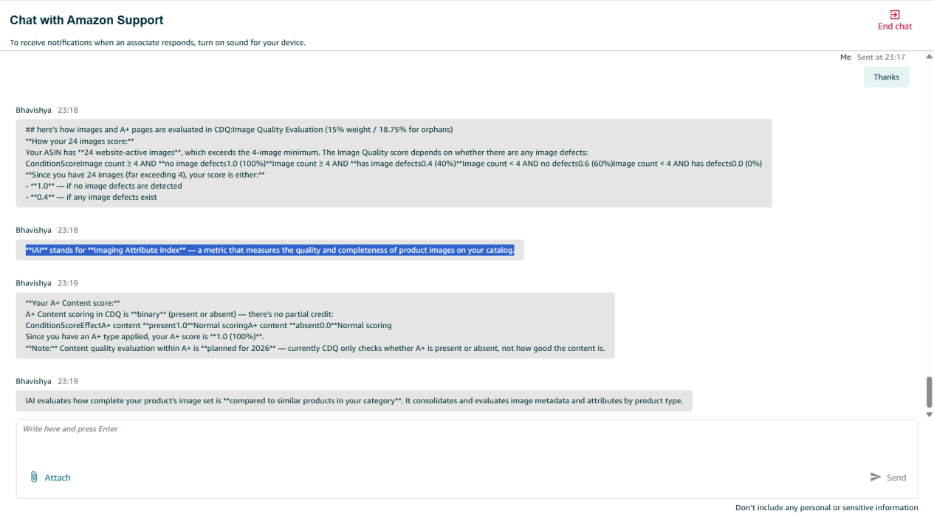
Your A+ Content score:
A+ Content scoring in CDQ is binary (present or absent) — there's no partial credit:
ConditionScoreEffectA+ content present1.0Normal scoringA+ content absent0.0Normal scoring
Since you have an A+ type applied, your A+ score is 1.0 (100%).
Note: Content quality evaluation within A+ is planned for 2026 — currently CDQ only checks whether A+ is present or absent, not how good the content is.

IAI evaluates how complete your product's image set is compared to similar products in your category. It consolidates and evaluates image metadata and attributes by product type.

Case ID- 12895480832
Hello from Amazon Selling Partner Support, Thank you for contacting Amazon Vendor Support.

I understand you would like guidance on how to improve your Promotion Quality Score (PQS) for ASIN B0GDCZ7XXX , and you are also inquiring about your sub-category score.

PQS - =10%*product promotion + 19%*brand +71%*listing quality
Regarding improving your PQS, the score is determined by three key components:

1.The first and most impactful is Listing Quality, which accounts for 71% of the overall score.

You can improve this by increasing glance views, boosting customer reviews and ratings, enhancing your Image and Detail Quality (IDQ) score through better images, A+ content, bullet points, and keywords, and growing your trailing 30-day sales.

2.The second component is Competitive Pricing — offering deeper discounts relative to category averages and providing rare or unique pricing (i.e., the lowest price compared to recent non-promotional prices) will positively impact your score.

3.The third component is Brand Metrics, which you can improve by growing your overall brand OPS, expanding your customer base, and increasing reviews across your brand portfolio.

about the sub-category score,
Sub Category Score

Sub Category Score

In
- Help
- ›
- Product management
- ›
- Edit products
- ›

Enhance listings
High-quality product detail page content boosts your product’s discoverability through search and filter inclusion, turns more browsers into shoppers, and makes it easier for customers to evaluate and purchase your products confidently, resulting in fewer returns and positive reviews. The Enhance Listings view in Catalog shows you listings that need improvement, along with their current listing quality and the specific attributes that impact quality. Where available, you’ll also see AI-generated suggestions to help you improve those attributes. The tool suggests improvements to product details such as titles, bullet points, and key attributes to help shoppers better understand your products and make confident purchase decisions.
As you review and apply updates, your Listing Quality automatically refreshes to reflect improvements, showing how close the listing’s product detail page is to Amazon’s quality standards. This helps remove the guesswork out of optimizing your product detail pages.
How to optimize listings
- Go to Items and navigate to Catalog.
- Click Enhance listings to view listings with improvement opportunities.
- Under the Enhance listings tab, click View enhancements for the ASIN you want to improve listing quality.
- Navigate to the side panel that shows all the opportunities to improve listing quality.
- Note: Where available, you will see the reasons for those opportunities underneath each attribute.
- Click Enhance listing for any ASIN you want to improve the quality of.
- View the side panel which opens to show all opportunities to improve listing quality, including the factors impacting your listing's quality and where available, AI-generated recommendations for these attributes.
- Note: AI capability is not supported when improving listing quality using bulk edits. For more information, go to Improving quality using bulk edits.
- You can enter your own value, update the AI-provided value, or use the AI-generated suggestions as they are.
- Note: It's your responsibility to review and verify all generated content thoroughly and ensure it is accurate and complies with all Intellectual Property and Listing policies. AI-generated content can include features and claims that were not in the listing's original content.
- After reviewing all opportunities, click Save and Finish to publish accepted updates.
- Note: The listing quality refreshes within 15 minutes of your publishing updates.
- Once all opportunities are addressed, a listing is removed from this view.

Alternative way to enhance listings
When editing an existing listing (One ASIN at a time), you may also see the option Enhance listing on the lest side of the listing form. Click View enhancements to view AI-suggested content for your listing. You can review and customize the generated content, then select Add to form. Click Save and Finish on the form to submit all updates.
Note: If your contribution is verified by Amazon, they will show on the product detail page within 48 hours. If, after the allotted period, your contributions do not show on the product detail page, it means that Amazon's system has selected another contributor's information that best describes the product based on the guidelines set by Amazon. The Listing Quality Indicator updates only when the update appears on the product detail page.

Listing Quality Indicator
The Listing Quality Indicator measures how complete and correct your product detail page is, based on two pillars:
- Content quality: Evaluates product data such as titles, bullet points, and key attributes for correctness, completeness, and policy compliance. Requirements vary by product type.
- Multimedia quality: Reviews image and A+ content quality and completeness.

Based on the quality of these two pillars, your listing is classified into one of the following listing quality categories:
- Poor: Listing violates Amazon detail page policies, for example, the title contains special characters (!, $, ?, _, {, }, ^, ¬, ¦.) or the listing is missing key information.
- Fair: Meets minimum requirements and all Amazon policies but lacks some key product information. Shoppers may need more details before purchasing.
- Good: Listing has reasonable depth of information (high-quality title and images, most primary attributes filled), with minor gaps remaining.
- Great: Near-perfect and shopper-ready. Listing is complete and high quality in both content and multimedia, with minimal missing secondary information.
- Optimized: Fully optimized listing that meets all current standards. Listing quality evolves over time, and you can check back periodically for new opportunities.

Note: The Listing Quality Indicator measures how your listing’s content and attributes compare to best-in-class listings in similar categories. It evaluates completeness, accuracy, and policy compliance, but does not account for dynamic factors such as offer price, fulfillment, or seasonality. While high-quality listings are generally better positioned to perform, the score should be used as a directional indicator rather than a predictor of visibility or sales.

https://sellerise.com/signup yangyayun2023@gmail.com
YANG2ya2yun6@2026
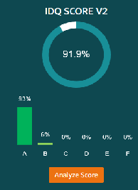
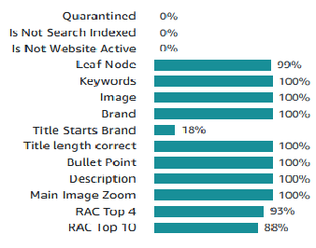
ASIN
Product Type
Title
Marketplace
Catalog Defect
Merchant Action
对接的运营人员
TODOLIST:
完成情况:
具体类目缺陷，Missing A+，Relevant attributes ranked [5..10] are incomplete
Top 10 relevant attributes are not identified 对应商家动作是Assign eligible PT and fill in relevant attributes ranked [1..10]
Fill in missing relevant attributes ranked [5..10]: maximum_current, item_weight

-

How to improve Amazon CDQ score.

How to improve Amazon CDQ score.
To improve your composite data quality score, focus on completing missing product attributes and ensuring accurate information. Here's how:
Your composite data quality (CDQ) score improves by systematically addressing six weighted components that together determine overall listing quality:
Focus on these six components:
1] Structured Attribute Quality (30%) — Populate and verify product specifications completeness and accuracy. Fill in all relevant attributes, especially the top 10 category-specific attributes required for your product category.

- Title Quality (25%) — Ensure your title complies with Amazon's style guide: stays under 200 characters, avoids redundant keywords and restricted phrases, uses proper casing, and is complete. Title policy violations result in Grade D/U with a score of 0.
- Image Quality (15%) — Upload a high-quality main image (1000+ pixels for zoom functionality) and include sufficient supplementary images. The score measures both image count and defect detection.
- Variation Quality (20%) — Set up product variations properly if applicable. Ensure variations are structured correctly and variation defects are addressed.
- Bullet Point Quality (5%) — Include well-written bullet points (typically 5-6 depending on category) that follow best practices: use relevant keywords, provide complete information, and follow proper formatting.
- A+ Content (5%) — Add enhanced A+ Content (rich media, comparison charts, enhanced images) to your product detail page.

Critical fixes to prioritize immediately:
- Egregious defects — Fix incorrect data in your top 6 most important attributes and ensure you're not missing more than 50% of your top 10 required attributes. These defects severely harm the CDQ score and customer experience.
- Policy violations — Correct any title issues and ensure your listing isn't index suppressed or website rejected.
about the first 6 RAI attributes under Structured Attributes:
The first 6 RAI attributes are the top 6 most important product attributes for your specific product type, identified by a Natural Language Processing (NLP) model called Relevance Attribute Index (RAI).

Band A attributes :
- Help identify and describe the essential nature of the product
- Describe fundamental characteristics that identify the product's core attributes
- Differentiate the product from other similar items
- Examples: For a laptop, this might include processor type, RAM, operating system, or display size

Band B attributes :
- Key product characteristics that differentiate between variants and versions of the same product type
- Allow customers to select their preferred option
- Attributes that differentiate between similar products
- Examples: For a laptop, this might include color, connectivity options, or specific port types
Together, Band A and B attributes form the "Depth Widget" — the detailed information visible on the product detail page that helps customers make informed purchasing decisions.

The first 6 RAI attributes are NOT fixed — they vary by product type. They are determined by the Relevance Attribute Index (RAI), an NLP model that ranks attributes differently for each category based on customer behavior.

What makes them "first":
The RAI model ranks all attributes for your product type (1st, 2nd, 3rd, etc.) based on which attributes customers care about most. This is determined by analyzing:
- Customer reviews
- Customer Q&A conversations
- Search queries
- Product titles and descriptions
- Manufacturer and competitor websites

about Discoverability
Product Type Classification
Launch ETATBD:
Discoverability refers to initiatives focused on helping customers find products through search and browse experiences. It involves:
- New Product Launch (NPL) Discoverability — A structured process to ensure new products are discoverable and visible to customers during launch
- Tracking key metrics across the customer funnel:Traffic (Glance Views per 100k customers)
Consideration (Add-to-Cart/Glance Views)加购率
Conversion (Units/Glance Views)转化率
- Tools like DART (Discoverability Analytics & Research Tool) — Provides insights into what customers are looking for from a search perspective and identifies attributes that require enrichment
For New Product Launches, the process includes:
- 6-12 months pre-launch: Submit NPL details and develop launch strategy
- Attend SAS Discoverability Office Hours (if Priority 1 or 2)
- 4-6 weeks prior: Submit A+ Content, enroll in Vine
- Launch day activities: Walk the store, ensure search/display campaigns are running

Product Type Classification is the system that determines the category/product type for an ASIN. Key points:
- Not yet launched in all marketplaces — For example, PT Classification is not yet launched in IE (Ireland) marketplace
- The classification affects how products are organized, searched, and filtered on Amazon
ETATBD stands for "Estimated Time to Availability"

"N/A weight" in the context of CDQ refers to components that are not applicable to certain ASIN types. Here's the breakdown:
Variation Quality — 20% Weight (or N/A for Orphan ASINs)
ComponentVariation ASIN WeightOrphan ASIN WeightVariation Quality20%N/A (redistributed)
What this means:
- Variation ASINs (products that come in different options/sizes/colors) — Variation Quality is evaluated at 20% weight
- Orphan ASINs (standalone products NOT in a variation family) — Variation Quality is N/A because it's not applicable

here's how images and A+ pages are evaluated in CDQ:Image Quality Evaluation (15% weight / 18.75% for orphans)
How your 10 images score:
Your ASIN has 10 website-active images, which exceeds the 4-image minimum. The Image Quality score depends on whether there are any image defects:
Condition Score Image count ≥ 4 AND **no image defects1.0 (100%)**Image count ≥ 4 AND **has image defects0.4 (40%)**Image count < 4 AND no defects0.6 (60%)Image count < 4 AND has defects0.0 (0%)
Since you have 10 images (far exceeding 4), your score is either:
- 1.0 — if no image defects are detected
- 0.4 — if any image defects exist

IAI stands for Imaging Attribute Index — a metric that measures the quality and completeness of product images on your catalog.

Your A+ Content score:
A+ Content scoring in CDQ is binary (present or absent) — there's no partial credit:
Condition Score Effect A+ content present1.0 Normal scoring A+ content absent0.0 Normal scoring
Since you have an A+ type applied, your A+ score is 1.0 (100%).
Note: Content quality evaluation within A+ is planned for 2026 — currently CDQ only checks whether A+ is present or absent, not how good the content is.

IAI evaluates how complete your product's image set is compared to similar products in your category. It consolidates and evaluates image metadata and attributes by product type.

亚马逊 Listing 质量得分 (Listing Quality Score) 打分系统的评估维度

CDQ 指标概述：
CDQ 指标旨在全面评估亚马逊listing单个商品目录数据质量对客户完整购买流程的影响。CDQ v3由亚马逊精选与目录系统团队（简称ASCS）于2025年3月推出，用于检测目录数据的完整性、准确性和一致性。

CDQ打分系统包括7个维度：Structured Attributes Quality(结构化属性质量权重占比30%)，Title Quality (标题质量权重占比25%)，Descriptive Summary Quality (Bullet Points) (描述性摘要质量/五点 描述权重占比5%)，
Image Quality (图片质量权重占比15%)，A+ Content Quality (A+ 页面质量权重占比5%)，Variation Quality (变体质量权重占比20%)，Product Type Classification (产品类型分类权重占比0-20%)合计100-120%，即100-120分

评估组 (Evaluation Group)， 组件 (Component)， 满分要求 (Requirement to achieve full quality score) ，权重（Weight）

a.结构化属性质量：是 Detail page (详情页)， Structured Attributes Quality(结构化属性质量)权重占比是30% ,所有呈现在详情页“产品概述”和“深度信息”组件中的适用属性必须完整且正确。All applicable attributes displayed in detail page Product Overview and Depth Information widgets are complete and correct.

b.标题质量：是 Detail page (详情页)， Title Quality (标题质量)权重占比是25%,标题完整、正确，长度和大小写规范，关键词覆盖良好，无关键词堆砌及违规内容。Title is complete, correct, with correct length and casing, good coverage of keyword tagging, no keyword redundancy and restricted content.

c.描述质量：是 Detail page (详情页)， Descriptive Summary Quality (Bullet Points) 五点描述 权重占比是 5%，五点描述数量大于等于3 条，且不含违禁关键词（关键词检查功能 ）。Number of bullet points >=3 and has no restricted keywords (keywords check ) 说明亚马逊对五点描述中违禁词、敏感词的自动化审查将更加严格。违禁词敏感词

d.图片质量：是 Detail page (详情页)， Image Quality (图片质量权重占比是15%),网站图片数量 大于等于 4 张，且无图片质量缺陷。有缩放效果，Number of website images >=4 and no image quality defect.support zoom

e.A+页面质量：是 Detail page (详情页)， A+ Content Quality (A+ 页面质量5%)权重占比是5%，拥有 A+ 详情页内容。It has A plus content.

f.变体质量：是 Detail page (详情页)， Variation Quality (变体质量)权重占比是20%，整个变体家族中的变体主题和变体主题属性必须全部正确且保持一致。

g.产品类型分类：是 Discoverability(可搜索性)，Product Type Classification (产品类型分类) 权重占比是0-20%，满分要求是有相应类目的节点且正确且相关
Discoverability refers to initiatives focused on helping customers find products through search and browse experiences. It involves:
- New Product Launch (NPL) Discoverability — A structured process to ensure new products are discoverable and visible to customers during launch
- Tracking key metrics across the customer funnel:Traffic (Glance Views per 100k customers)
Consideration (Add-to-Cart/Glance Views)
Conversion (Units/Glance Views)
- Tools like DART (Discoverability Analytics & Research Tool) — Provides insights into what customers are looking for from a search perspective and identifies attributes that require enrichment

评分总分100-120，评分等级
A++： >100 （100-120） 极高 （加分）
A+： 85-100 高质量
A： >85 尚可
B： 70-85 低质量-无缺陷
C： 0-69.99 低质量-非严重缺陷
D： 0 低质量-严重缺陷
U： n/a 低质量-政策违规

CDQ v3指标 细则划分（更多详情参见CDQ v3指标（新增） ）
策略违规： 索引/网站抑制，标题政策违规（标题不完整、冗余、包含受限关键词、长度或大小写错误）关键词堆砌，含违禁词 敏感词等策略违规

严重缺陷： 大多数PT中前6项相关属性错误或前10项相关属性完整性<50%*，变异严重缺陷
（* 部分Softline PT遵循不同的相关属性排序逻辑）

结构化属性：相关属性的完整性与正确性， 前4/10相关属性最优（前4/10相关属性完整性），Top 6 + Band A/B属性分析 -> 详情页中客户反馈的关键信息:
based on which attributes customers care about most. This is determined by analyzing:
- Customer reviews
- Customer Q&A conversations
- Search queries
- Product titles and descriptions
- Manufacturer and competitor websites

标题：标题完整性、大小写及长度，标题长度不超75字符数,HIGHLIGHT（高亮标题）不超125字符数；
总标题长度不超200字符数 ，（标题+HIGHLIGHT的长度建议在75-200个字符数），受限与冗余关键词 建议标题以品牌名开头（标题完整性、有品牌名称权重），(不堆砌词)

五点与说明： 五点数量≥3, (卖点>=3)，有商品描述有1条商品要点 ，（遵循0/1/3原则），基础功能0遗漏，1个最核心最主要功能卖点，3个以上的魅力卖点 （不喧宾夺主）有3条或以上商品要点
关键属性全都填写

图像与A+: 图像数量≥4， 有4张或以上图片 +5%, IAI >=0.4 ,有A+型页面，（有高级A+ ），图片信息完善度 ， 主图有缩放功能 ，图片alt具有相关属性的完整性， 详情页中客户反馈的关键信息的A+页面 ，图片上有效像素占比85%以上，亚马逊S3图库系统标准,第一个要点是看产品在整张图片上的占比，其次就是打标签让系统收录你listing的关键词，然后它就会相对应地去匹配产品。

变体: 变体主题属性需保持一致性、正确性及避免重复，变体有丰富属性，变体数量在2个及2个以上，主题属性需保持一致性、正确性及避免重复

可发现性： （权重占比 0-20%）具有细分类目 叶节点（具有准确和详细的类目细分节点即Node ID）， 包含关键词，类目词，节点， 有分类叶节点，有搜索关键词，

缺陷组件 - 评分① 细则如下

细分补充：标题质量和结构化属性 - 评分 标题质量 里面再分A,B,C等级，TQS即 TQS（Title Quality Score）逻辑
标题质量（25%）
我们采用 TQS 逻辑进行标题质量评估。在CDQv3指标体系中，标题评估维度包括完整性、准确性、篇幅（标题长度-字符数）、大小写规范、关键词标注、关键词冗余度及内容限制性。根据以下标准，标题质量按A-C等级进行评分，并附相应分数。

A级 - 代表高质量标题。（CDQ 标题质量评分=100%）
• 标题完整性评分≥0.6（标题中标注3个及以上属性）且
• 标题冗余度评分 = 1（无冗余）且
• 标题长度 <=200 且
• 管套评分 > 0 且
• 特殊字符评分 = 1（无不可读字符）且
• 限制性短语评分 = 1（无限制性短语）
其中说明管套评分是指标题中包含了 至少1个管道符（|）或分隔符，用于清晰分隔不同信息段
标题长度是包括75字符和HIGHLIGHT125字符，总长度不超过200字符
标题完整性评分：包含品牌名，主关键词，3个及以上核心属性，标注适用人群使用场景，意图，特征，无语法错误
标题冗余度评分：无关键词堆砌，冗余，关键词不重复

B级——未违反政策规定，但在上述至少一个维度（CDQ 标题质量评分≥50%）未达到高质量标准

C级 - 违规标题（商品ASIN存在违规行为， CDQ 标题质量评分为0%，CDQv3等级为U级，CDQv3评分值为N/A）
• 标题完整性评分 < 0.4（标题中标记的属性少于2个）或
• 标题冗余度评分 <= 0.6（标题中同一语境下使用超过2个重复词汇/短语）或
• 标题长度 > 200 或
受限短语阈值 < 1（存在受限短语）

亚马逊标题规则：1. **标题（Title）**
- 是否 ≤200 字符，推荐 75-≤200 字符。
- 是否有特殊字符 (!, $, ?, { }, _, ^, ¬)。
- 是否有重复词堆砌（同词 >2 次）。
- 是否包含促销语（Best, Free Shipping, Cheapest good,Best Seller, Top Rated, #1best等）。
- 是否误导性或包含竞品品牌 / 商家名。
- 结构是否符合：品牌 + 核心产品名 + 关键属性（颜色/规格/材质等）。
- 是否存在 “Review Listing Updates” 风险提示因子。
敏感词（包括但不限于以下） such as "antimicrobial," "antibacterial," "antifungal," "prevents bacteria," "resists mildew," "removes mold," "sanitizes," "disinfects," "sterilizes," or claims about controlling pests, allergens, or microorganisms,uv,uv sterilizes, Bacteria, pesticides,Anti-Mites ,Detoxify.anti-mites,Drugs
违禁词
避免重复和堆砌
熟悉移动端展示（移动端友好） 标题，建议**75–200字符**，移动端可读性强，兼顾GEO与可读性

标题里面尽量不要写Gift (礼品), Free (免费), Warranty (保修), Guarantee (保证), 折扣/促销等词汇
健康/医疗/杀虫声明：Antimicrobial (抗微生物), Antibacterial (抗菌), Anti-Mites (防螨), Sanitize (消毒), Detoxify (排毒) pesticides(杀虫剂)Insecticide，marijuana， Heroin， Drugs
品牌词侵权类词汇， 通用产品侵权类词汇,营销与促销类词汇， 引导评论与联系方式类词汇, 类目特定违禁词, 格式与字符限制词, 平台与物流关联词,

**整体合规性**
- 是否存在冲突或误导
- 是否有 AI 自动修正风险（不当标点、字符、违规词）
- 是否有类目特殊限制（如医疗/儿童/杀虫剂/食品额外要求）
- 埋词，表达清晰符合亚马逊规则标题，最新亚马逊的二段式标题，在测试，产品基本信息，差异点，
- 移动端可读性好
亚马逊后台的要求 原文
亚马逊商品名称要求
字符数限制 商品名称不应超过 200 个字符，包括空格
促销内容 商品名称不应包含促销用语，如“free shipping ”或“100% quality guaranteed ”。
特殊字符：商品名称不应使用以下特殊字符：!、$、?、_、{、}、^、¬、¦。其他特殊字符，如 ~、#、<、> 和 *，只能在特定上下文中使用。例如，您可以使用这些符号作为商品编码（“款式 #4301”）或测量值（“<10 磅”）。不允许使用特殊字符作为装饰。例如，商品名称“Paradise Towel Wear Co. Beach Coverup << Size Kids XXS >>”不符合要求，因为尺码前后存在过多使用符号的情况。
大写： 请勿全部使用大写字母。每个单词的首字母大写，介词（in、on、over、with）、连词（and、or、for）或冠词（the、a、an）除外

数字： 使用阿拉伯数字，而不是英语单词 使用数字 “2”，而不是“two”。
字词重复：商品名称中不能有重复字词。例如，“Baby Boy Outfits Baby Boy fall Winter Clothes Baby Boy Long Sleeve Suspender Outfit Sets”是不符合要求的商品名称。介词、冠词和连词可以在商品名称中使用两次以上。但是，品牌名称还是不能出现两次。如果品牌名称的一部分出现在不同的上下文中（例如“Old Navy and Navy Blue”），则不会视为重复

长度： 保持商品名称简洁，最好不超过 200 个字符（建议80 - 200 个字符） 冗余： 避免使用重复词语或信息
主观性评价用语： 请勿使用主观性用语 主观性评价用语示例包括“Hot Item”或“Best seller”。
缩写词： 计量单位可以缩写 计量单位缩写示例：“cm”“oz”“in”和“kg”。

型号： 包含特定分类的型号
规则如下：
- 遵守所有相关风格指南，避免使用 HTML、JavaScript 或其他代码。
- 不包含不适宜的内容，例如淫秽或冒犯性材料、链接或联系信息、情节剧透、评论或评论请求以及广告等。
- 准确地分类和描述您的商品。
- 如果商品被认定为故意采用不准确的描述、分类错误或欺骗性的描述，以规避亚马逊的任何分类、商品和商品信息限制，我们可能会对您的账户采取纠正措施，包括但不限于立即终止销售权限。
- 避免为已有详情页面的商品创建重复页面。
- 为新商品或新版本创建新的详情页面。
- 仅创建与主要商品相关的有效“变体”。有关更多详情，请参阅 ASIN 创建政策。
- 如需以不同的商标（品牌或制造商名称）销售商品，请创建一个新的 ASIN，而不是编辑现有的 ASIN。这也适用于现有 ASIN 未列出品牌或制造商（如无品牌商品）的情况。切勿修改现有 ASIN 的商标信息。
商品信息编写政策
- 请遵守所发布商品的相关风格指南。您可以在亚马逊开店服务快速入门风格指南中找到适用于所有商品的通用规则。某些类型的商品还需要遵循额外的风格指南。您可以在特定分类的模板中找到全套风格指南。
- 请勿在商品详情页面使用 HTML、JavaScript 或其他类型的代码。在特殊情况下，您可以在描述中使用换行符 </br>。
- 商品详情页面中的商品名称、描述、要点或图片不允许出现以下任何内容：
- 色情、淫秽或冒犯性内容。
- 电话号码、地址、电子邮件地址或网站 URL。
- 供货情况、商品价格或状况详情。
- 其他可下单网站的链接或备选配送服务（例如免费配送）。
- 对媒介类商品（图书、音乐、影视）的剧透，包括透露对故事的悬念或结局非常关键的详细情节。
- 评论、引言或感言。
- 请求买家发布正面评论的言辞。
- 图片、照片或视频中的广告、促销材料或水印。
- 有时效性的信息，例如宣传活动、研讨会或讲座的日期。
- 在“无品牌”商品的商品信息中显示品牌特定信息，如品牌的知识产权。
- 受限短语，如“符合 FSA/HSA 要求”
- 商品名称不能超过 200 个字符（含空格）。虽然 200 个字符是上限，但我们建议您最多使用 80 个字符，因为手机屏幕会截断较长的商品名称。某些分类允许的字符数可能更少。请参阅“特定分类的模板”了解详情。
- 大写字母只能用于每个单词的第一个字母。请勿将属性全部大写。这一点适用于商品名称、要点和商品描述。禁止在每个单词的开头使用表情符号、表情图标或其他符号。要了解更多信息，请参阅商品名称要求和指南。
- 在亚马逊上销售的任何商品均应遵守我们的商品信息标准。如果未遵守这些标准，则会导致负面买家体验，并可能会导致您的销售权限被暂时或永久取消，这包括但不限于下列商品：
- 必须准确地分类所有商品。要了解有关如何对商品进行正确分类的更多信息，请参阅我们的帮助页面：商品分类工具、分类树指南和 ASIN 创建政策。
- 必须清楚地编写商品名称、商品描述和要点，以帮助买家了解商品。
- 商品信息必须准确且可信，且不可在商品的品质或特征方面误导买家。要了解有关允许使用的声明的更多信息，请查看我们的禁售商品声明政策。
- 商品图片必须遵守亚马逊图片标准以及任何特定分类图片指南。要了解更多信息，请参阅商品图片要求。
- 确保商品详情页面概述了对商品功能至关重要的其他任何事项。

结构化属性（30%） 细分，正确的优先级要高于完整

评估指标涵盖产品概述（前6项RAI属性）及深度可视化组件（Band A与B属性）
评分 = 完整且正确属性的权重总和
评分体系：完整性 (Completeness) vs 准确性 (Accuracy)

缺陷组件——评分② 细则如下
变异质量（20%）

🔴 严重缺陷——需立即采取行动：
错误属性值 · 单位制混用 · 变体信息冗余 · 本地化错误 · 子项重复
🟡 非严重缺陷——随时间推移改善：
未标准化值 · 格式不匹配 · 变异主题错误

描述性总结（5%）

≥3个bullet → 100% · ≥1个bullet → 50% · 无bullet → 0%

A+内容（5%）

存在 → 100% · 不存在 → 0%

